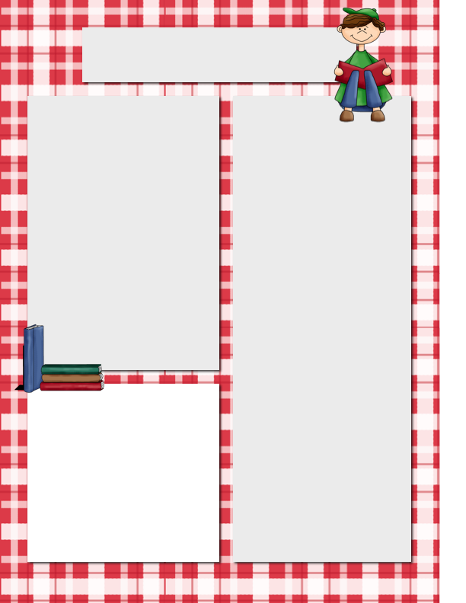

**Spelling and Vocabulary**

**Spelling:**

**sad, dig, jam, glad, list, win, flat, if, fix, rip, kit, mask, as, his, sandwich and picnic**

**Vocabulary:**

**curly, straight, floppy, drooled, weighed, stood, collars, row**

Please practice spelling words and vocabulary definitions orally every night!

We will have a test on the last day of every week. This will include spelling, vocabulary, questions from the story for the week and grammar.

Please visit [www.misterszymanski.com](http://www.misterszymanski.com) for extra practice, videos, etc.

**Star Student of the Week**

**Dates to Remember**

Friday Reading MAPS Test

**Please Note…**

Parents,

We will be taking the beginning of the year Reading MAPS/NWEA test on Friday.

It is VERY important to arrive on time and well rested. This would be a great day to eat breakfast at home with a yummy, nutritious meal.

This is an important test!

Szymanski News

***September 8, 2014***

Meet Siefora! She has shown that she can make deep connections and have brilliant thoughts even in the first week!

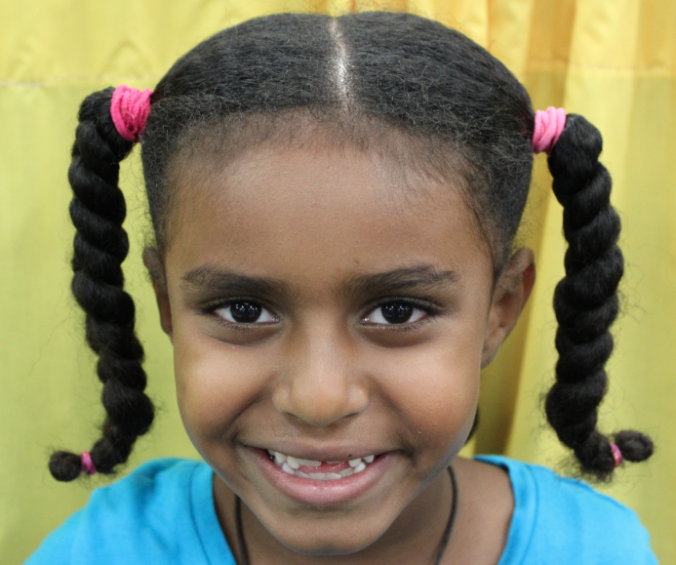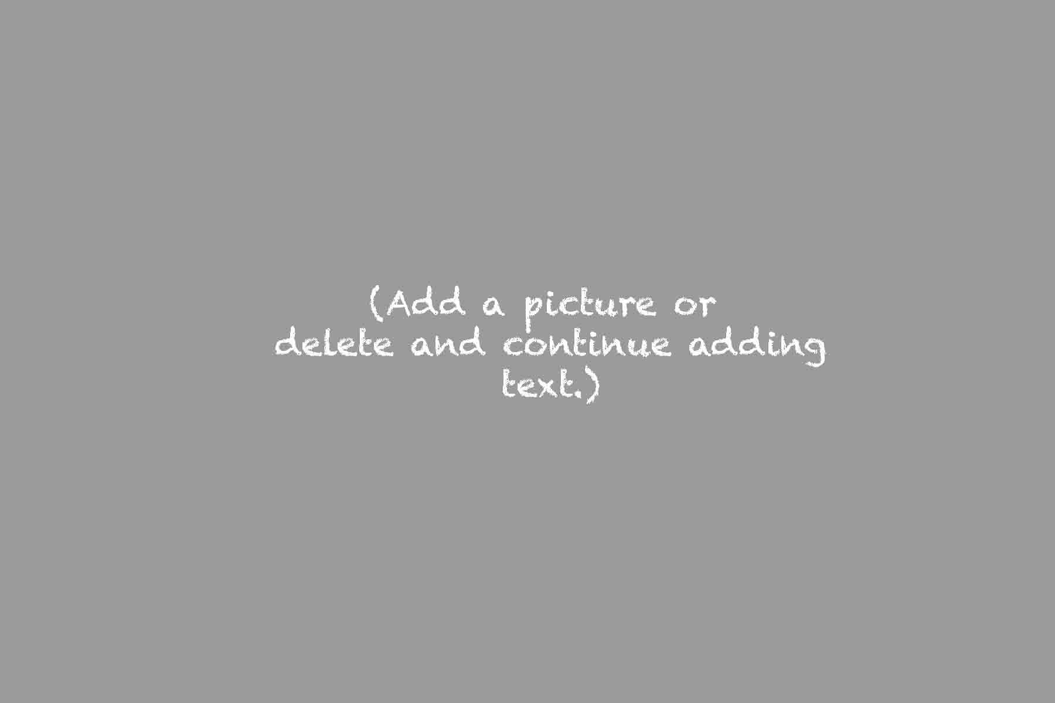

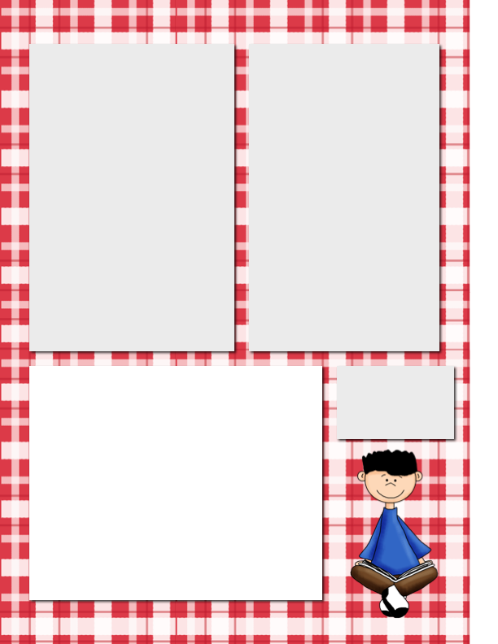

**Homework to Expect**

**This Week**

**Monday**: Rdg.- pages 4, 7 and 11

Math – page 17

**Tuesday**: Rdg – page 10, 3 and 5

Math – page 23

**Wednesday**: Rdg pages 13, 2, 7

Math- 29

**Thursday**: Rdg - Pages 12, 14, 15

Math – 35

**Reading Log**: Students should read for **20 minutes each day** and fill out their reading log. This will be collected at the end of every month. I will not collect this every day but will periodically check it. This is expected EVERY day – weekends too!

**ISBE Numbers**

Several parents have asked about ISBE numbers for our texts.

**Reading (Journeys**):

978-0-547-88547-6

**Math (Go Math):**

978-0-544-29547-6

Note: We are using the “national” texts. Texts often come in “state” version. Please keep all shipping documents incase you accidentally ordered the wrong book. The Go Math comes in 11 separate books. If you need help, reach out to me. I am not an expert but will do what I can to make sure you have the right book.

Happy 2nd Week!

**Daily Behavior Calendars**

Parents, we have been practicing using our behavior clip chart and colors. Each day, the students will color in their final color. Please look at the color and talk to your child about their day! I was THRILLED to have TWO “outstanding” students last week. My nephew uses the colors at his school and said, “Wow!!!!” Great job Siefora and Jenny! ☺