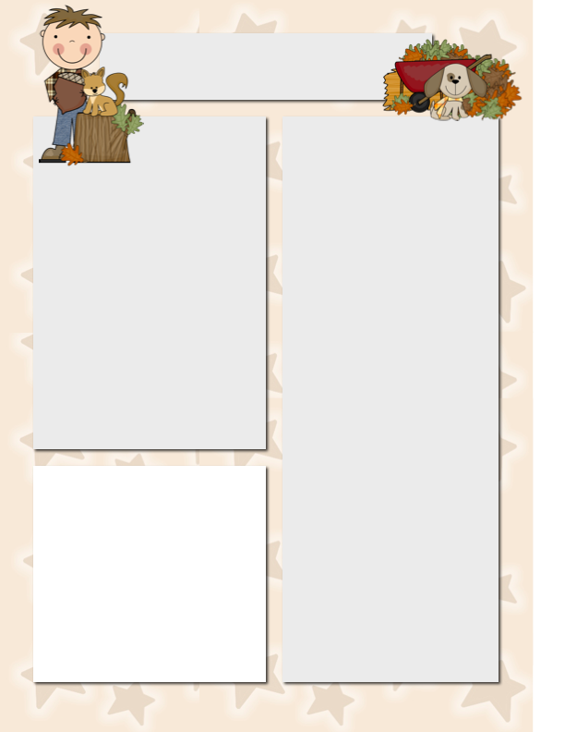

**Spelling and Vocabulary**

Spelling Words

doze

nose

use

rose

pole

close

cute

woke

mule

rode

role

tune

home

joke

wrote

ice cube

Vocabulary Words

insects

dangerous

scare

sticky

rotten

screaming

breeze

judge

**Dates to**

**Remember**

Sept. 30 Book Order Due

Oct. 3 Nutcracker Field Trip

Money Due

Oct. 13 Columbus Day

Nov. 11 Veterans Day

**Friday Folders Volunteer…**

Please email Mr. Szymanski at [cityofszmanski@aol.com](mailto:cityofszmanski@aol.com) to volunteer in the classroom. Volunteer spot is still not functioning properly.

The Szymanski News

***September 28, 2014***

Meet Kiya! She shows she is caring and sensitive every day. She is darling with a great sense of humor and is always willing to help Mr. Szymanski.



**Star Student of the Week**

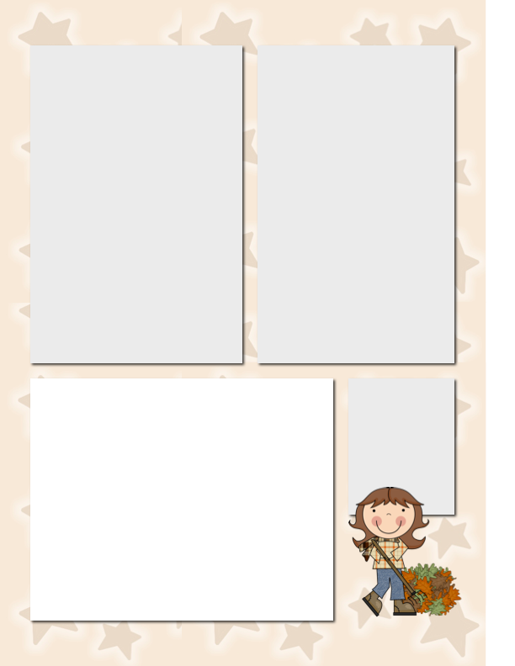

Scholastic Book Orders

Mr. Szymanski will process Scholastic Book Orders tomorrow, September 30th. Don’t forget to get your orders in by that day! The kids love the new books they order and the class gets points when you order to enrich our class library with the students’ favorite books too!

We love the Fall!

Upcoming Social Studies Theme and Science

We have been focusing on the five senses in Science and will be moving toward a more heavy focus on community in Social Studies. Mr. Szymanski is going to build a slightly different spin on this unit as we explore concepts of global citizenship and developing a small action project where the students develop a project to take action. It should be interesting to see where the students go with this.

Veggie U Coming

Mr. Szymanski has written a grant where the students are going to be participating in hands on activities around growing vegetables and plants in the classroom. It is a fantastic organization where we start out sampling various veggies and then participate in a curriculum designed by folks in Ohio. I am very excited about this! Materials are scheduled to be shipped to us in about a week!

**Want to Add a Picture Instead of Text?**

Click on a text box. Go to the insert menu above and insert a picture! ☺

**Homework to Expect**

**This Week**

Monday: blah, blah, blah, blah, blah, blah, blah, blah, blah, blah

Tuesday: blah, blah, blah, blah, blah, blah, blah, blah, blah, blah

Wednesday: blah, blah, blah, blah, blah, blah, blah, blah, blah, blah

Thursday: blah, blah, blah, blah, blah, blah, blah, blah, blah, blah