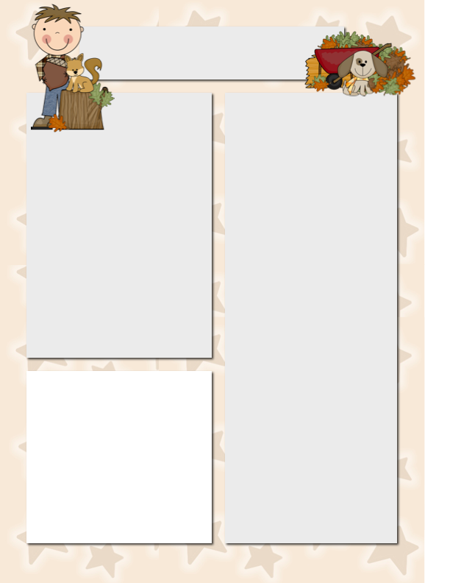

**Spelling and Vocabulary**

Spelling:

wet

job

hug

rest

spot

must

left

help

plum

nut

new

hot

Vocabulary

remembered

porch

crown

spend

stuck

visit

cousin

plane

NOTE: Volunteer Spot is still **NOT** working even though Mr. S. watched tutorials after tutorials this weekend. For now, email me directly to volunteer.

**Dates to**

**Remember**

September 17 Open House

September 18 NWEA Math Test

**Please Note…**

If you have not signed up for “Remind 101,” Please do. I am able to send reminder texts out to you to keep you updated “real time.”

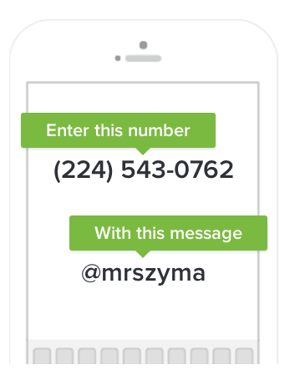

Szymanski News

***September 15, 2014***

Meet Indigo! Indigo has shown that she has tremendous ability to make personal, thoughtful connections during class discussions when we talk about a text.



**Star Student of the Week**

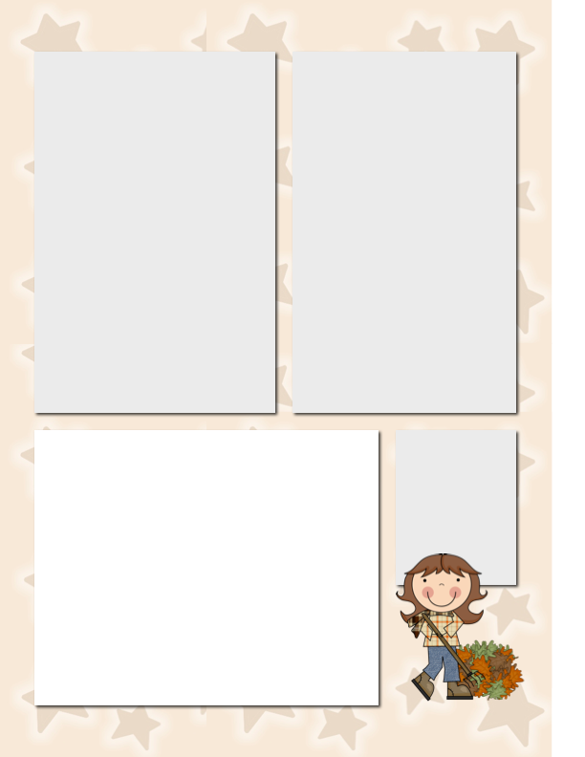

**“Try Again” for Credit**

If a child does poorly on an assignment or test, I usually will write a note on it to fix mistakes to receive **partial** credit.

I do this to help the child bring p their grade but also to get a helping hand at home as well. This is typically done for students when their grade on something is a “D” or lower and when I know they can do better. If this is the case, please remind your child to put those items in my hands FIRST THING when they walk in the door in the morning.

A “low grade” does not automatically mean that I will allow corrections. I try to take into account the assignment, effort and context of the assignment.

**Scholastic Book Order**

Please encourage your child’s reading by considering ordering scholastic books. The classroom gets points with every order and we are able to get free, often exciting, new books. The kids love your books and the classroom books!

Visit [www.misterszymanski.com](http://www.misterszymanski.com) to order books.

Visit our class website for extra materials for Reading!

**Don’t Be Tardy for Our Party! ☺**

Please make sure your child is on time to school. Even though we have breakfast in the classroom, learning starts at this time. We have work that we start during breakfast. When a child is tardy, they are often playing catch up for a while.

**Reminder:** This Friday will have Reading, Spelling, Math and NWEA tests! I will try to have fun inserted somehow. ☺