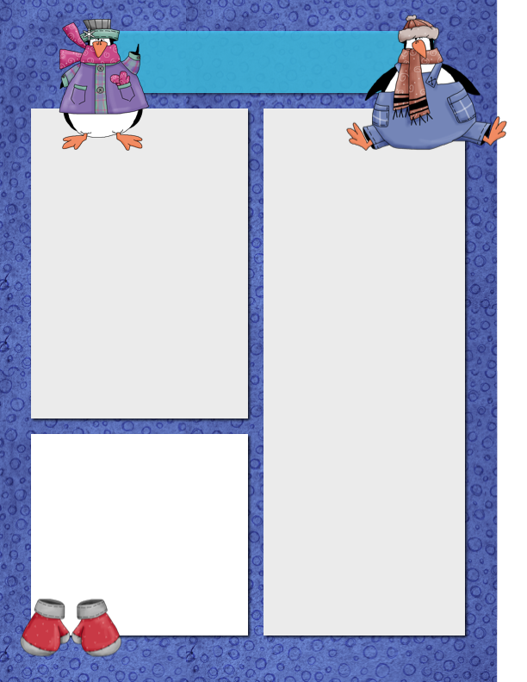

Meet Ronan! This little penguin is so smart and such a good helper in class!

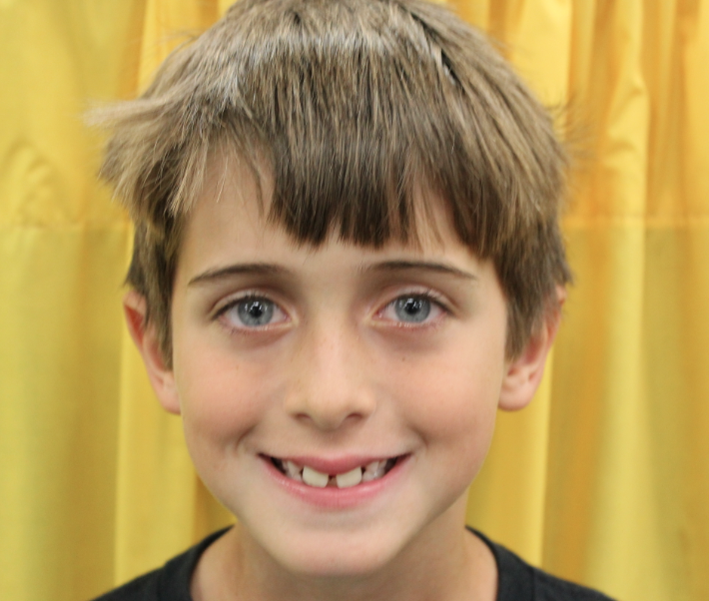

Szymanski News

***January 4, 2014***

**Dates**

**to Remember**

January 10 – Room 108 Potluck

First/Second Week: MAPS

Testing

**Please Note…**

For the potluck, please reach out to other parents for details. This is not a Disney organized event. Mr. S. will be there!

MAPS Test – I am unsure of the exact date. Will send a Remind 101 message when I get information.

**Star Student of the Week**

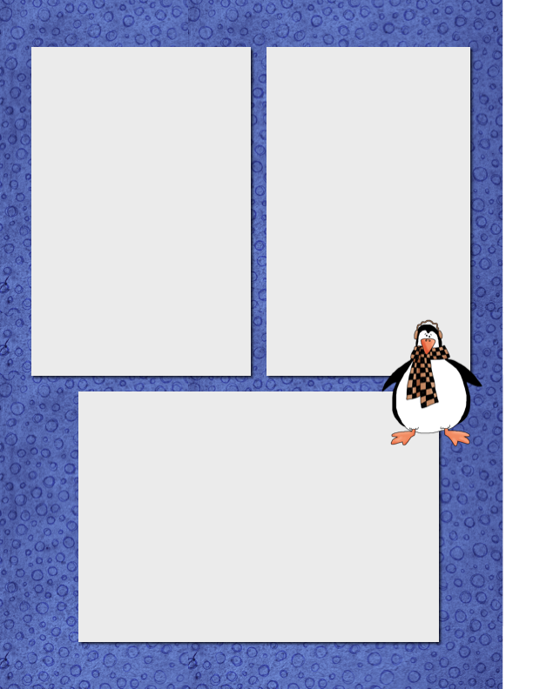

**Happy New Year and Thanks!**

I just wanted to take a moment to give a huge thanks to each and every one of you – parents and kids! I did not even look at any of the gifts until I got back on Saturday. If I had, I would have spent every moment writing thank you notes; there was so much to do before I left. Your kindness and generosity was truly touching!

Also, I can’t begin to tell you how much I appreciate your support, flexibility and connection to me in Antarctica and South America. It brought tears to my eyes as I was sitting on the boat and had my blog light up with questions, comments and participation. The people at National Geographic were certainly paying attention! I was so proud of all of them!

Have a wonderful New Year! I am very happy to be back. I missed the kids tremendously! XOXOXO! Mr. S.

**The big jump! Yikes!**



**Want to Add a Picture Instead of Text?**

Click on a text box. Go to the insert menu above and insert a picture! ☺

**Homework to Expect**

**This Week**

Monday: blah, blah, blah, blah, blah, blah, blah, blah, blah, blah

Tuesday: blah, blah, blah, blah, blah, blah, blah, blah, blah, blah

Wednesday: blah, blah, blah, blah, blah, blah, blah, blah, blah, blah

Thursday: blah, blah, blah, blah, blah, blah, blah, blah, blah, blah