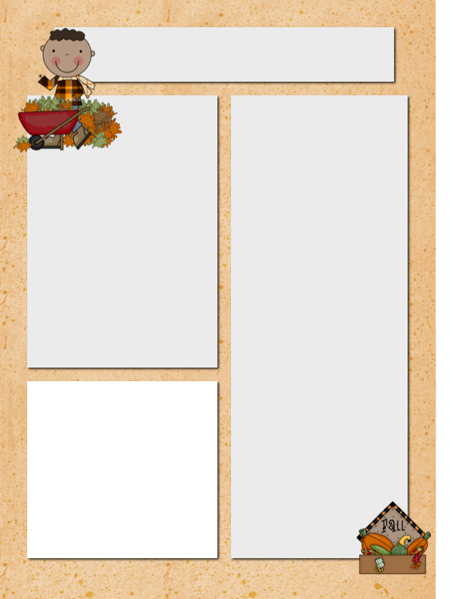

Meet Dawson! He is a deep thinker and makes great connections to things we do in class. Did you know he has been whale watching?

**Spelling Words**

spin

clap

grade

swim

place

last

test

skin

drag

glide

just

stage

slip

drive

dime

price

**Vocabulary Words**

wonderful

noises

quiet

sprinkled

share

noticed

bursting

suddenly

**Dates to**

**Remember**

Oct. 10 Reading and Spelling

Test

Oct 10 Progress Reports

Oct. 13 Columbus Day – No School

**Please Note…**

We have some new friends added to our class this week. I apologize for our weekly newsletter being tardy. I had my hands tied up with the POD reading group changes and welcoming new kiddos to our class.

Szymanski News

***October 7, 2014***

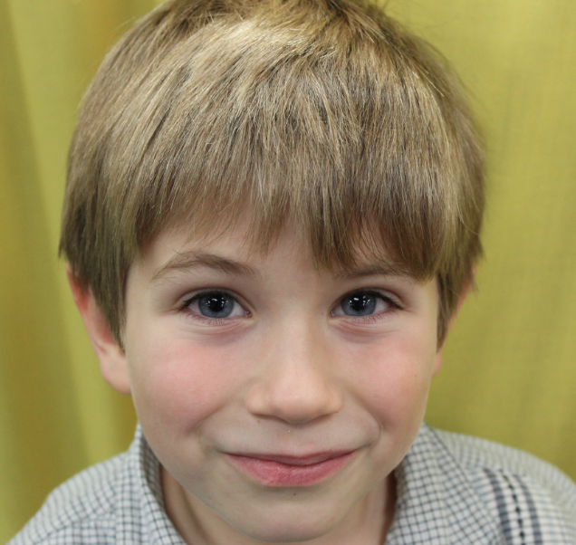

**Star Student of the Week**

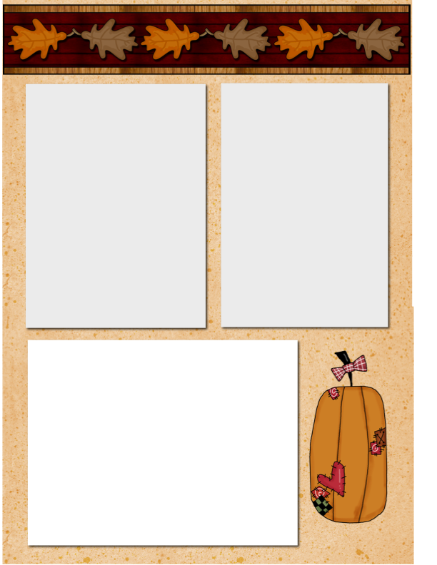

**Emailing Mr. Szymanski**

Please be sure to email Mr. Szymanski at [cityofszymanski@aol.com](mailto:cityofszymanski@aol.com) I know that I recently included my personal email on a group message asking for volunteers for the Museum of Science and Industry field trip in December.

I have heavy spam controls on that email account and honestly get TONS of spam to sort through because I like to shop online. ☺ The email that I gave is for parents only and it is less likely that I will miss an email.

**“Redo” Work and Tests**

For now, it is my practice that when a child does poorly on something, I put a note on it saying, “Please correct and send back for partial credit.” I do reserve the right to make a judgment on circumstances around the assignment, effort put forth on the original task and complexity of the work to be done.

It is my goal that ALL students are successful and that there is great learning when revisiting something that perhaps could have been done better the first time.

Good News: I am seeing much improved quality in tests and work! It is because of your hard work. Thank you for this the past few weeks! It is paying off. ☺

**Halloween Costumes**

Wanting to just send a “heads-up” about costumes. Please remember to have appropriate themed costumes. Masks are not permitted. Weapon toys, etc. are NEVER okay in a school. Your child’s costume should be something that can easily put on over clothing.