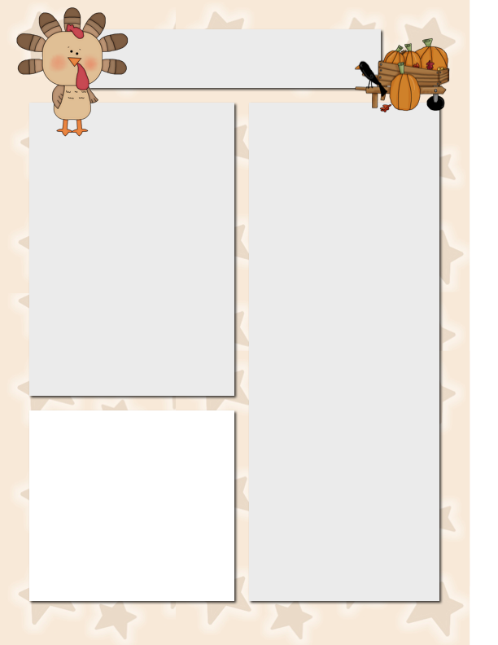

Szymanski News

***November 10, 2014***

**Spelling**

I’m

don’t

isn’t

can’t

we’ll

it’s

I’ve

didn’t

your’re

that’s

wasn’t

you’ve

us

them

they’re

wouldn’t

**Vocabulary**

millions

choices

drift

simple

weaker

wrapped

disgusting

decide

**Dates to Remember**

Nov. 10 **LSC Meeting – 5:30 p.m.**

Nov. 11 **No School**

(Veterans Day)

Nov. 12 **Parent Teacher Conf.**

(No School for Students)

Nov. 14 Film Festival Field Trip

Money Deadline!

Nov. 21 **Scholastic Book Order Due**

**Film Festival Field Trip**

**Please Note…**

Please turn in your field trip money and permission slip ASAP!

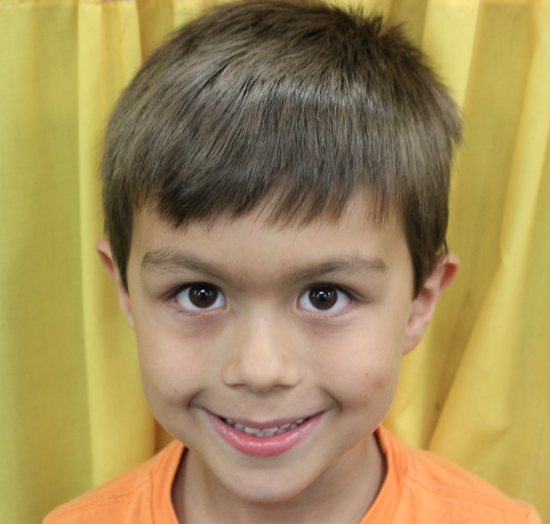

**Star Student of the Week**

Meet Nicky! He has a heart of gold and always puts his best forth his best effort! He makes me proud every day!

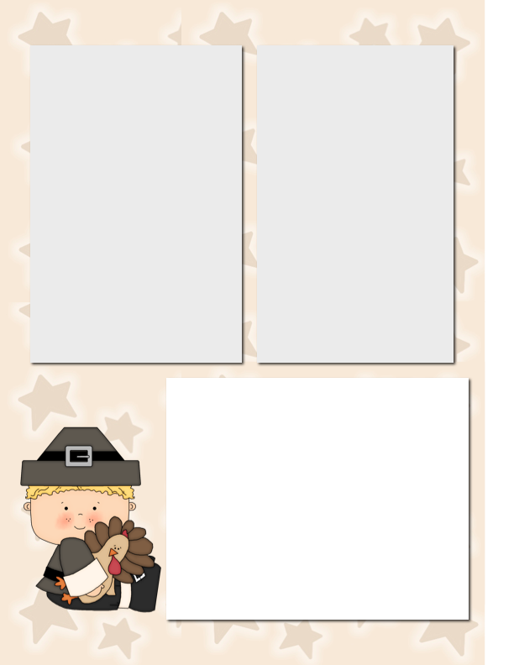

**Reading – Lesson 10 (this week)**

We will not be completing the reading lesson this week. **So, THIS time when your child tells you that we do not have a reading test and spelling test on Friday, they are correct.** ☺

The reading test will be moved to the following week due to the 3 day week that we have!

Have a safe and relaxing Veterans Day!

**Report Card Pick-up**

Please note that I have to limit conferences to 5 to 10 minutes, especially if a parent is waiting. We have 33 kids in the class, one Mr. Szymanski and a finite amount of minutes! Please understand that I have to be brief and focused to ensure that all get seen! Kindly, remember to sign in. ☺

**Want to Add a Picture Instead of Text?**

Click on a text box. Go to the insert menu above and insert a picture! ☺

**Homework to Expect**

**This Week**

Monday: blah, blah, blah, blah, blah, blah, blah, blah, blah, blah

Tuesday: blah, blah, blah, blah, blah, blah, blah, blah, blah, blah

Wednesday: blah, blah, blah, blah, blah, blah, blah, blah, blah, blah

Thursday: blah, blah, blah, blah, blah, blah, blah, blah, blah, blah