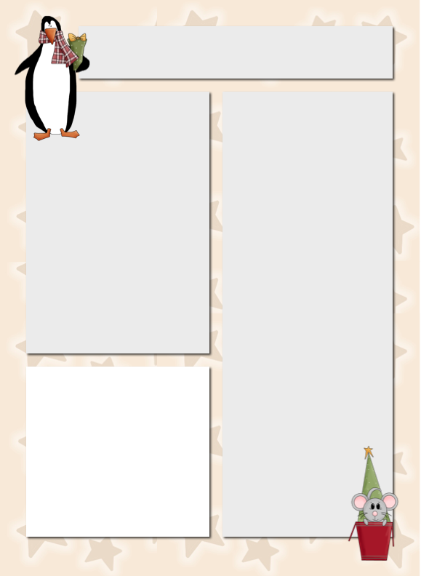

**Spelling**

**hens**

**eggs**

**ducks**

**bikes**

**boxes**

**wishes**

**dresses**

**names**

**bells**

**stamps**

**dishes**

**grapes**

**jets**

**frogs**

**stitches**

**fences**

Vocabulary

**understand**

**gathered**

**impatient**

**impossible**

**believe**

**problem**

**demand**

**furious**

**Dates**

**to Remember**

Dec. 3 Museum of Science and Industry

Dec. 7 Mr. Szymanski leaves

for Antarctica!

Dec. 11 Field Trip: Joffrey Nut Cracker

**Daily Expedition Reports**

Get Daily Expedition Reports following my adventures in Antarctica! Email me at [cityofszymanski@aol.com](mailto:cityofszymanski@aol.com) with the letters “DER” in the subject. I will sign you up! **Please do so ASAP**. The closer we get the harder it will be for me to do things!

**In reality, if you would like this PLEASE submit by Wednesday of this week!**

Meet Liga! She is one of the sweetest, kindness little students a teacher could EVER wish for! She works so hard!

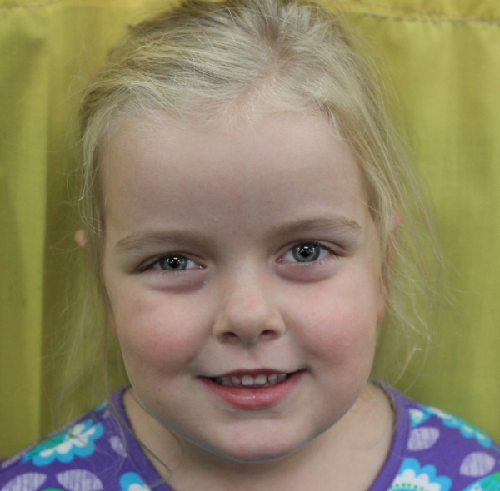

**Star Student of the Week**

Szymanski News

***December 1, 2014***

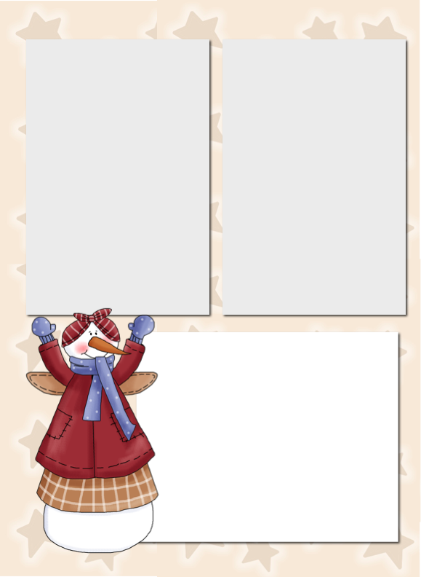

**Contact for Mrs. Davidson and Mrs. Bartgen**

Please note the following contacts for our two “guest substitute extraordinaires” who so kindly are stepping in starting Monday! Please copy each substitute when you have a question so they are both in the loop of your needs.

Mrs. Bartgen – jlbartgen@cps.edu

Mrs. Davidson – alliedavidson21@gmail.com

Note: They are not covering the same days for each week.

**Field Trip Volunteers**

**Scheduled**

**December 3rd** – **Museum of Science and Industry**

**Volunteers:** Siefora, Leo, Sophia, Blake, Olivia, Josiah, Aaliyah, Shozib

**December 11th – Joffrey Ballet, Nutcracker**

**Volunteers:** Shannon, Charles, Myles, Chaitan, Olivia, Fabrizio, Josiah, Mariyah, Sophia, Almond, Matt, Eddie,

**Museum of Science and Industry Field Trip**

For this field trip, students MUST bring disposable items. (**Absolutely NO lunchboxes, thermoses, etc**.). We are eating at the museum and totally everything must be thrown out. We aren’t allowed to carry uneaten food, beverages through the museum.

Please put your child’s name, school name and room number on the outside of the lunch.

**Parents:** Arrive no later than 9:00 a.m.