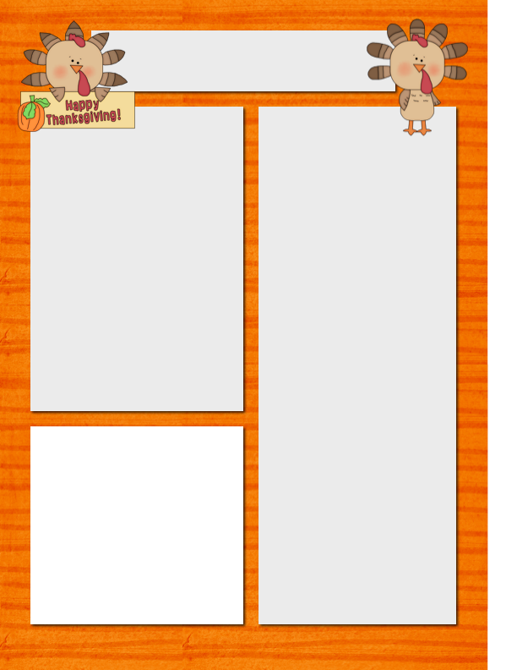

Meet Jenny! She always, always tries her very best! Every day she impresses me with the effort and desire to work hard! She is “my peanut.” ☺

Szymanski News

***November 3, 2014***

**Dates to Remember**

Nov. 3 **PTA Meeting 7 a.m.**

Nov. 7 **No School For Kids**

(School Improvement Day)

Nov. 10 **LSC Meeting – 5:30 p.m.**

Nov. 11 **No School**

(Veterans Day)

Nov. 12 **Parent Teacher Conf.**

(No School for Students)

Nov. 21 **Scholastic Book Order Due**

**Film Festival Field Trip**

**Please Note…**

The Thanksgiving Holiday is November 26th (Wednesday) through November 28 (Friday).

**Spelling**

liked

using

riding

chased

spilled

making

closed

hoping

baked

hiding

standing

asked

mixed

sleeping

teasing

knocking

**Vocabulary**

tunnel

curled

height

direction

toward

healed

brag

tease

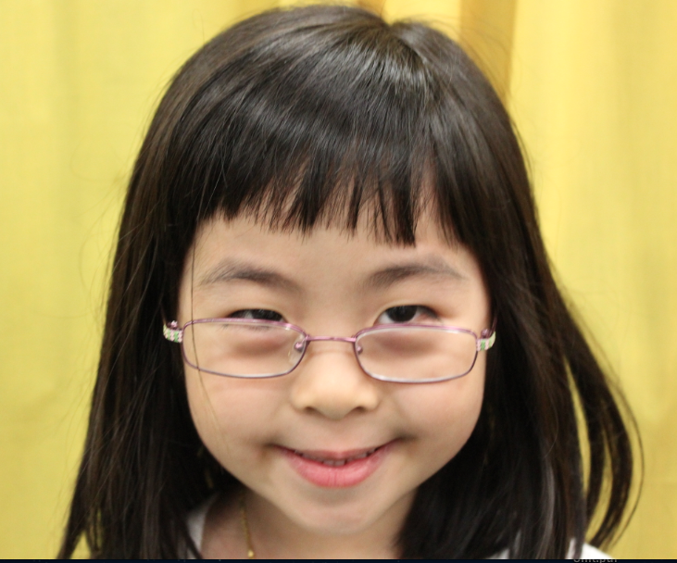

**Star Student of the Week**

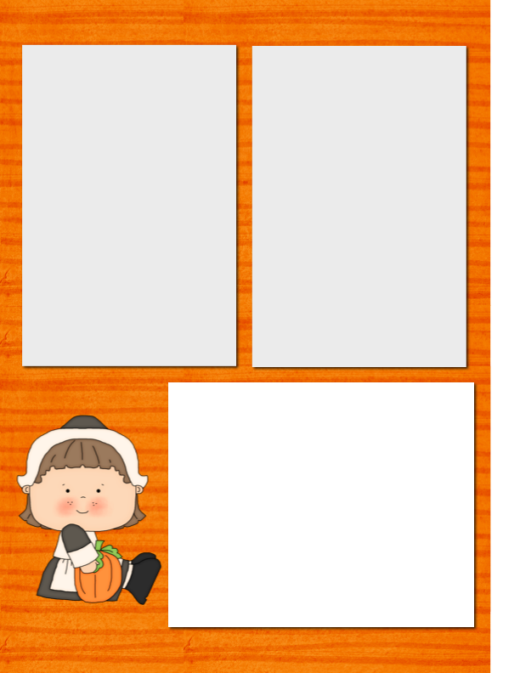

Gifted CAC

We had a gifted meeting and the administration has decided to move our Gifted CAC unit until much later in the school year – May. I know that several parents asked at the beginning of the year for the CAC dates. It looks like both of our units will be in the distant future – March and May.

Thank You!!!

I wanted to say to all of the parents “THANK YOU” for coming out and enjoying the Halloween festivities last Friday. I think it is safe to say that we all had an absolute ball! In all of my years in teaching, this was (without a doubt) the most fun I have ever had! Even more, the extra hands helping with various tasks from sorting candy, to organizing papers to changing window displays was such help. We can’t forget those Friday Folders, too! It was a very special day!

**Field Trips Coming Up**

We have a field trip scheduled for November 21 (Friday) for the Film Festival and December 3rd for the Museum of Science and Industry. I wanted to give you some advanced notice because money collection will begin soon for both of these trips.

**Want to Add a Picture Instead of Text?**

Click on a text box. Go to the insert menu above and insert a picture! ☺

**Homework to Expect**

**This Week**

Monday: blah, blah, blah, blah, blah, blah, blah, blah, blah, blah

Tuesday: blah, blah, blah, blah, blah, blah, blah, blah, blah, blah

Wednesday: blah, blah, blah, blah, blah, blah, blah, blah, blah, blah

Thursday: blah, blah, blah, blah, blah, blah, blah, blah, blah, blah