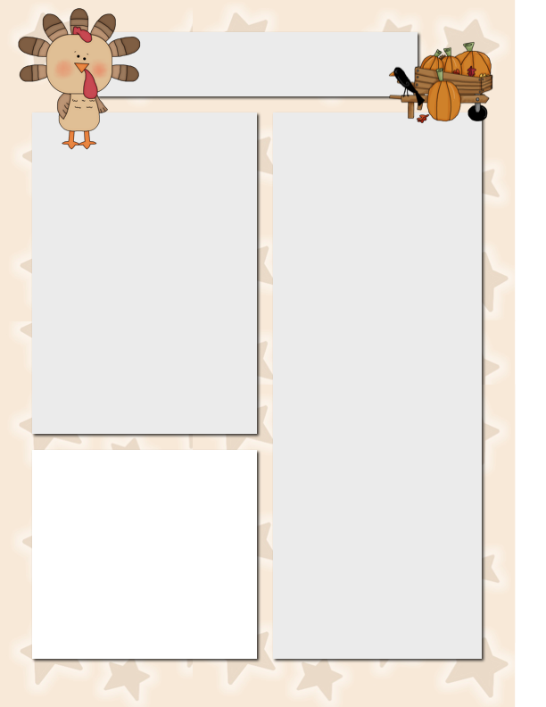

**Spelling**

I’m

don’t

isn’t

can’t

we’ll

it’s

I’ve

didn’t

your’re

that’s

wasn’t

you’ve

us

them

they’re

wouldn’t

**Vocabulary**

millions

choices

drift

simple

weaker

wrapped

disgusting

decide

Note: Reading and Spelling test is on Tuesday!

Szymanski News

***November 17, 2014***

**Dates to Remember**

Nov. 18 Reading and Spelling

Test

Nov. 18 Mrs. Velez visits the

kids during Chinese!

Nov. 21 **Scholastic Book Order Due**

**Film Festival Field Trip**

**Nov. 21 MOVIE NIGHT!**

**Please Note…**

Please come to school with a DISPOSABLE lunch on Friday for the field trip. Label the lunch with your child’s name and room number. For field trips, everything needs to be thrown out when lunch is over.

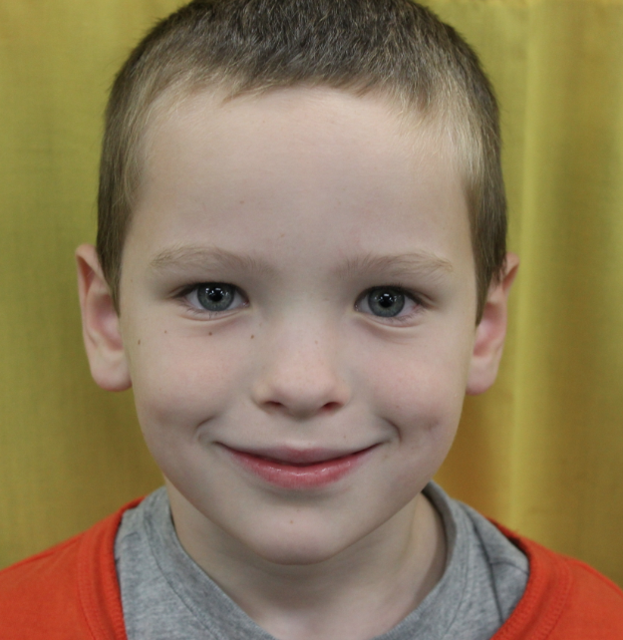

**Star Student of the Week**

**Meet Charlie! In just one day of Mr. S. “fussing” he displayed excellence in work quality, handwriting and being one of the biggest “love bugs!” I am so proud of him! I love having him in our class.**

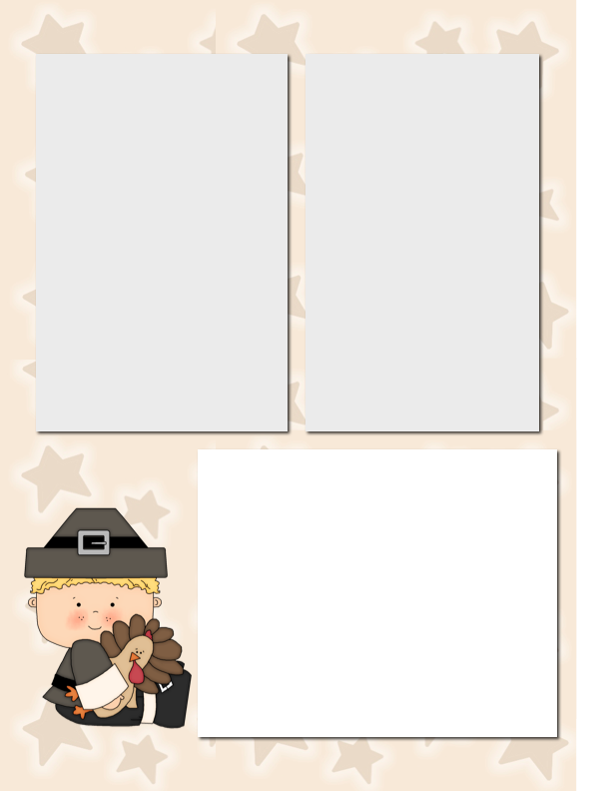

**World Problem Topic:**  I spoke with many parents about identifying a current event/world problem to tackle as a class. I really tried to talk the class out of the Ebola Virus – I mean REALLY tried. The vote was so clear that they have questions and probably a lot of uncertainty about it. Parents were very open to it when I talked to them. So, we will move forward with it. I wanted to communicate how we will tackle this and all future world themes.

**First**, we will define the problem (What is a virus?). Then we will tie it to the Ebola Virus directly. **Next,** we will investigate the communities and countries that have been most directly affected by the outbreak. **Then**, we will look at some world organizations and see what they are doing – the good and bad. I want the kids to have a critical eye to all kinds of efforts. **Lastly**, we will then develop an action that they can do to communicate and do something to positively impact the world. It might be a letter writing campaign, video or art project. I do not intend to bring up scary topics into this. I believe the kids have valid questions and concerns. I want to help answer them.

**Is your name not on the list?**

I very well might have made a mistake. There has been this new policy where we have to get names WAY in advance and it makes things **SUPER complicated** when trying to plan multiple field trips.

First, I apologize in advance. Second, **do NOT panic**. ☺ It can be fixed! The only exception is the Nutcracker because parents paid WELL ahead of time and we have to account for every seat.

**Field Trip Volunteers**

**Scheduled**

**November 21** – **Film Festival**

**Volunteers:** Almond and Olivia

**December 3rd** – **Museum of Science and Industry**

**Volunteers:** Siefora, Leo, Sophia, Shannon, Olivia, Josiah, Aaliyah, Shozib

**December 7th – Joffrey Ballet, Nutcracker**

**Volunteers:** Shannon, Charles, Myles, Chaitan, Olivia, Fabrizio, Josiah, Mariyah, Sophia, Almond, Matt, Eddie,